Map Coloring Problem using CSP
Aim
To implement the Map Coloring Problem using Constraint Satisfaction Problem (CSP) in Python.
Objective
- To assign colors to regions of a map.
- To ensure that no two adjacent regions have the same color.
- To solve the problem using backtracking.
Algorithm
- Define the map as a graph.
- Define the available colors.
- Select an unassigned region.
- Assign a color that satisfies all constraints.
- Check adjacent regions.
- If constraints are violated, backtrack.
- Repeat until all regions are colored.
- Display the solution.

FLOW CHART
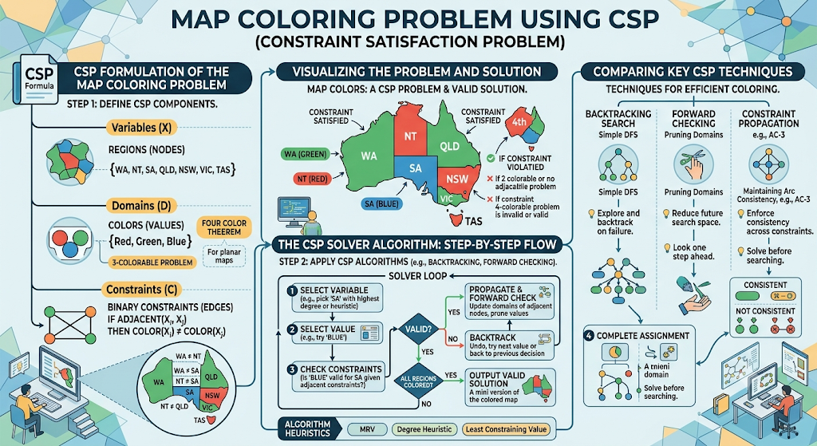
PYTHON CODE

graph = {
'A': ['B', 'C'],
'B': ['A', 'C', 'D'],
'C': ['A', 'B', 'D'],
'D': ['B', 'C']
}

colors = ['Red', 'Green', 'Blue']

color_map = {}

def is_safe(node, color):
for neighbor in graph[node]:
if neighbor in color_map and color_map[neighbor] == color:
return False
return True

def solve(node_list, index):
if index == len(node_list):
return True

node = node_list[index]

for color in colors:
if is_safe(node, color):
color_map[node] = color

if solve(node_list, index + 1):
return True

del color_map[node]

return False

nodes = list(graph.keys())

if solve(nodes, 0):
print("Map Coloring Solution:")
for node in color_map:
print(node, "->", color_map[node])
else:
print("No Solution Found")

RESULT
